`Mission Statement: The mission of the Baden Academy Charter School is to inspire personal excellence by cultivating the inherent gifts and talents present in all children by providing a curriculum which integrates the arts and sciences in a highly interactive, hands-on environment resulting in outstanding academic and personal achievement. We will emulate the classical rigor that will create a small, scholarly society of renaissance thinkers who value our humanity and our environment.
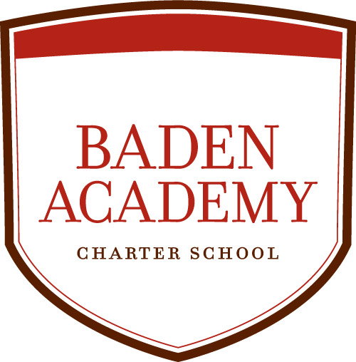
Vision Statement: Baden Academy Charter School is dedicated to providing all students with the skills and experiences necessary for them to develop and begin realizing their personal goals and objectives, as well as to become active and contributing members of their communities. The school's emphasis on creative inquiry, critical thinking, and interdisciplinary collaboration will equip students with skills that will be crucial to successfully navigating our complex, challenging, and ever-changing world. Students will be provided a strong foundation to help to encourage sound ethical and moral decisions through a character-education program, while a comprehensive and highly personalized wellness initiative will help to shape healthy lifestyles from an early age. Baden Academy's engagement of core academic subjects in an arts-rich environment is designed to ignite each child's innate curiosity, and to instill a desire for learning that is life-long in its breadth and scope.
- Call to order
- Roll Call
Marta Karwoski___ John Silbert ___ Connie Mabin ___ Lisa Houy___ Thomas Ward____ Roylin Petties ___ Charlie Camp ___
- Pledge of Allegiance
- Motion to Adopt Agenda
- Recommend that the board approve the minutes from the January 23, 2023 regular board meeting.
- Public Comment, on agenda items only
- Correspondence
- Administrative Report
- Financial Report
  - Recommend the Board approve the list of invoices paid in January 2023 in the amount of $360,754.62 from the general fund.
  - Recommend the Board approve the financials dated January 31, 2023.

- Recommend that the Board approve the 2023-2024 School Calendar
- Recommend that the board approve the CertaPro Painters bid for the painting of the gymnasium, third floor classrooms, and the exterior of the walking bridge, in the amount of $18,200.

- Recommend that the Board approve the Biometric Data Privacy Policy.

- Recommend the Board approve Federal Fiscal Compliance Policy.
- Executive Session
- Recommend that the Board approve the personnel report dated February 2023
- Board Member Questions & Comments
- Date of next Board Meeting is March 20, 2023
- Adjourn

